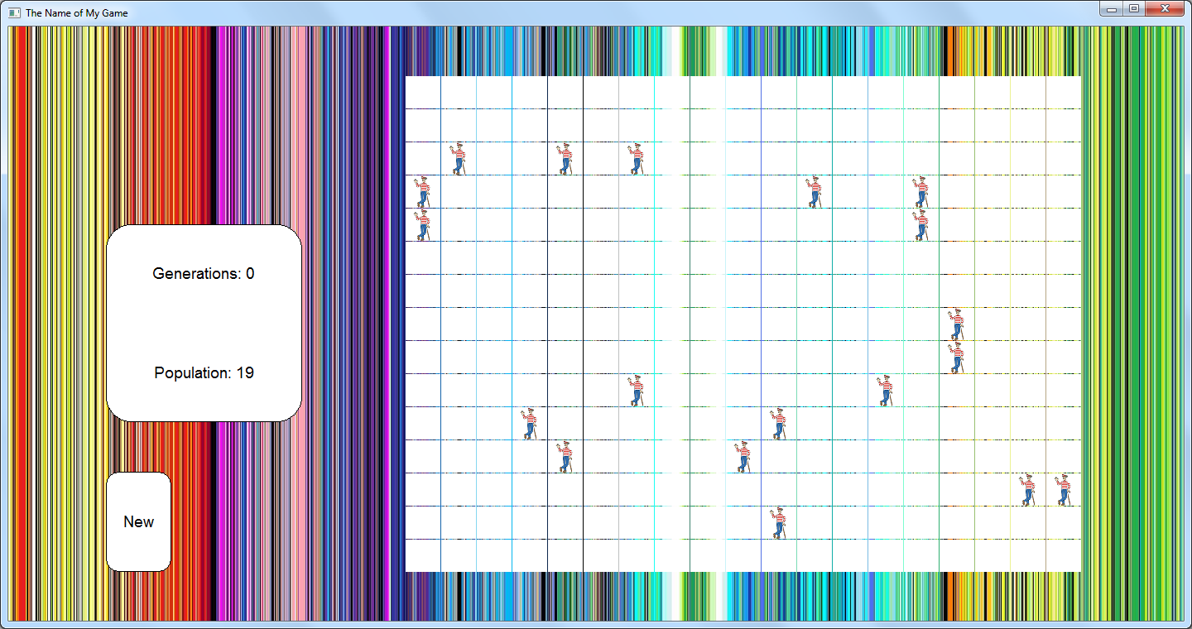

The Name of My Game

The story behind this game is…. In this example, the backstory should motivate the player to help Waldo survive in his striped world!

The goal of this game is….

Click on…

Use the arrow keys to…

You will get points for….

The game is over when….

Waldo appreciates your help!